1. What is the result of the code, and explain?

>>> X = 'iNeuron'

>>> def func():

print(X)

>>> func()

Ans: The Result of this code is iNeuron. it is because the function intially looks for the variable X in its local scope but since there is no local variable X, it returns the value of global variable X i.e iNeuron. Please find the output below:

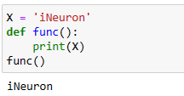

**2. What is the result of the code, and explain?**

**>>> X = 'iNeuron'**

**>>> def func():**

**X = 'NI!'**

**>>> func()**

**>>> print(X)**

**Ans:** The Result of this code is NI! because the function initially looks for the variable X in its local scope. If X is not available, then it checks for variable X in the global scope. Since here the X is present in the local scope, it directly prints the value NI! and does not look for a variable in global scope.

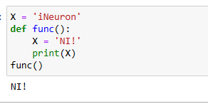

**3. What does this code print, and why?**

**>>> X = 'iNeuron'**

**>>> def func():**

**X = 'NI'**

**print(X)**

**>>> func()**

**>>> print(X)**

Ans: The output of the code is NI and iNeuron. X=NI is in the local scope of the function func(). Hence the function prints the x value as NI. X = 'iNeuron' is in the global scope. Hence print(X) prints output as iNeuron

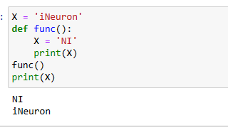

**4. What output does this code produce? Why?**

**>>> X = 'iNeuron'**

**>>> def func():**

**global X**

**X = 'NI'**

**>>> func()**

**>>> print(X)**

**Ans:** The output of the code is NI. The global keyword allows a variable to be accessible in the current scope. Since we are using global keyword inside the function func, it directly accesses the variable in X in global scope and changes its value to NI. Hence the output of the code is NI as shown below.

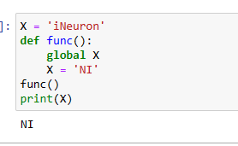

5. What about this code—what’s the output, and why?

>>> X = 'iNeuron'

>>> def func():

X = 'NI'

def nested():

print(X)

nested()

>>> func()

>>> X

Ans: The output of the code is NI and iNeuron. Output of func() is 'NI' because it has a variable X as 'NI' in its local scope whereas Output of X is 'iNeuron' because it refers to variable X that is having global scope instead of referring to a variable having a local scope in a function.

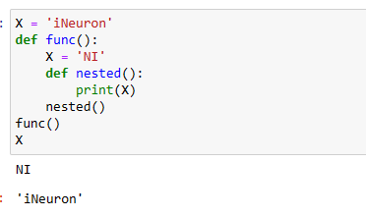

**6. How about this code: what is its output in Python 3, and explain?**

**>>> def func():**

**X = 'NI'**

**def nested():**

**nonlocal X**

**X = 'Spam'**

**nested()**

**print(X)**

**>>> func()**

**Ans:** The output of the code is Spam. nonlocal keyword in python is used to declare a variable as not local.Hence the statement X = "Spam" is modified in the global scope. Hence the output of print(X) statement is Spam

